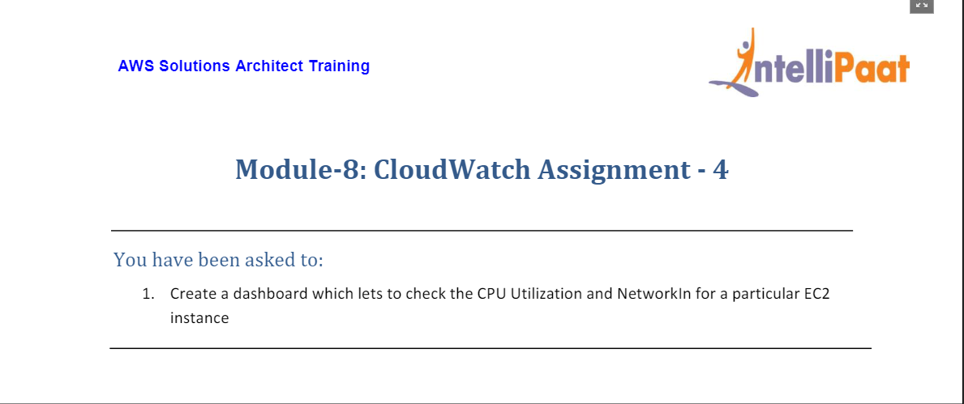

1. For this assignment, first we need a running EC2 instance. We launch an instance as shown below.

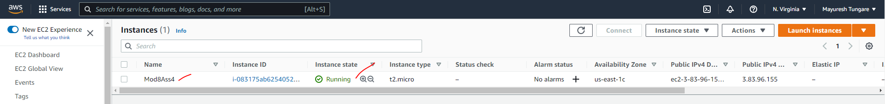

1. We now created a dashboard to check CPU Utilization and NetworkIn for this instance. For that we head to CloudWatch and then click on Create dashboard as shown below:

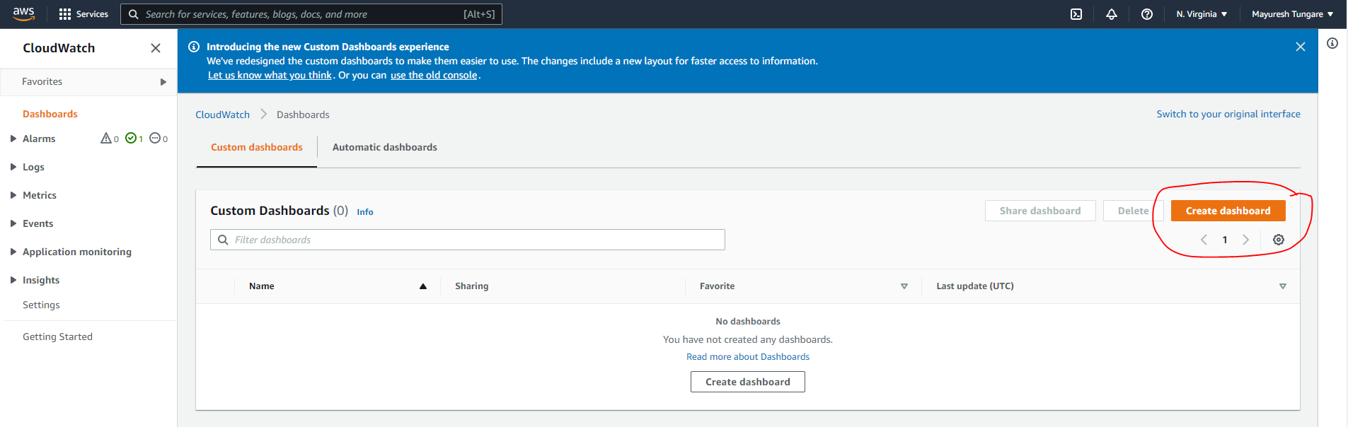

1. When we click on Create Dashboard, it asks us to provide a name for the dashboard. The dashboard is created (as shown below) and is empty for now – it does not display any data for now.

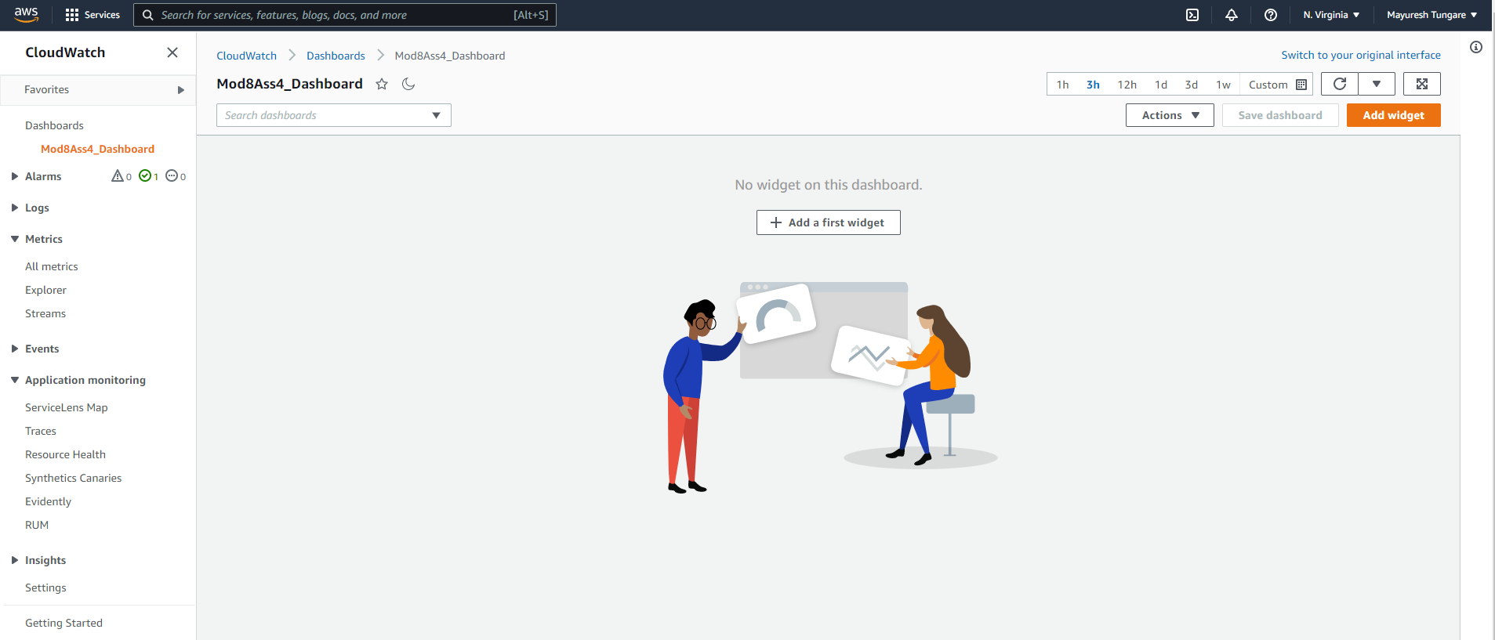

1. In the next step, we then choose Add widget and empty template as shown below.

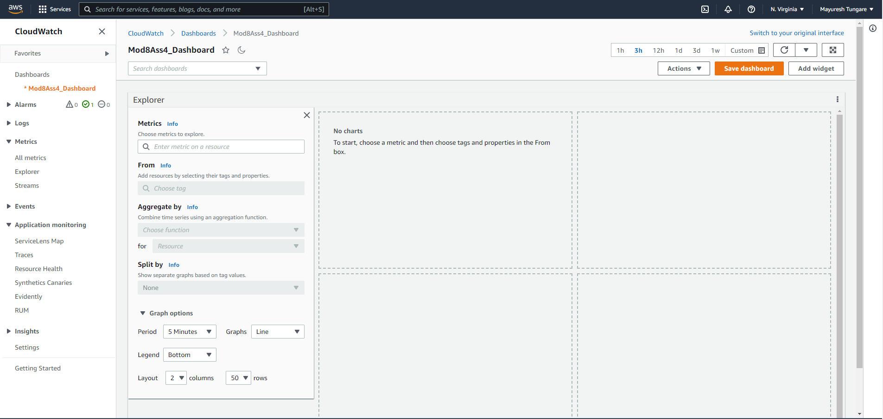

1. Next, we add charts for two required metrics – CPU Utilization and NetworkIn. Once we select both then we need to click on Save Dashboard.

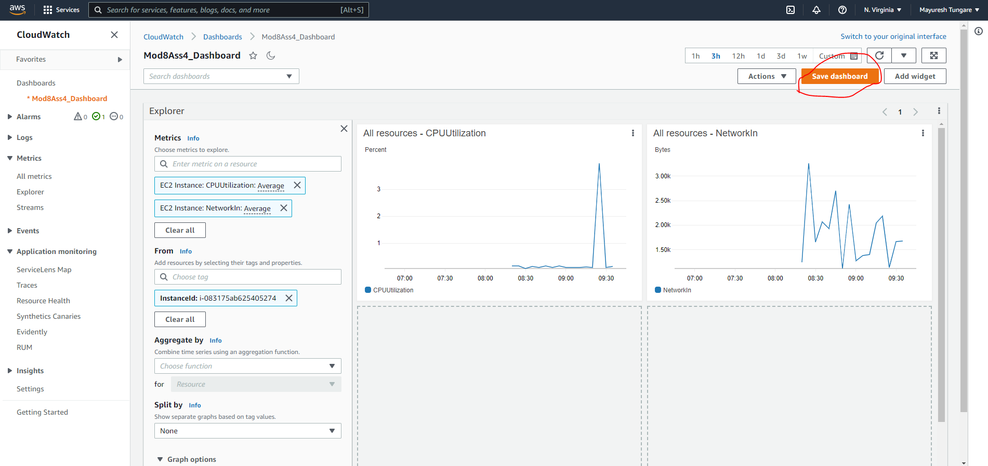

1. The custom dashboard is now ready as shown below:

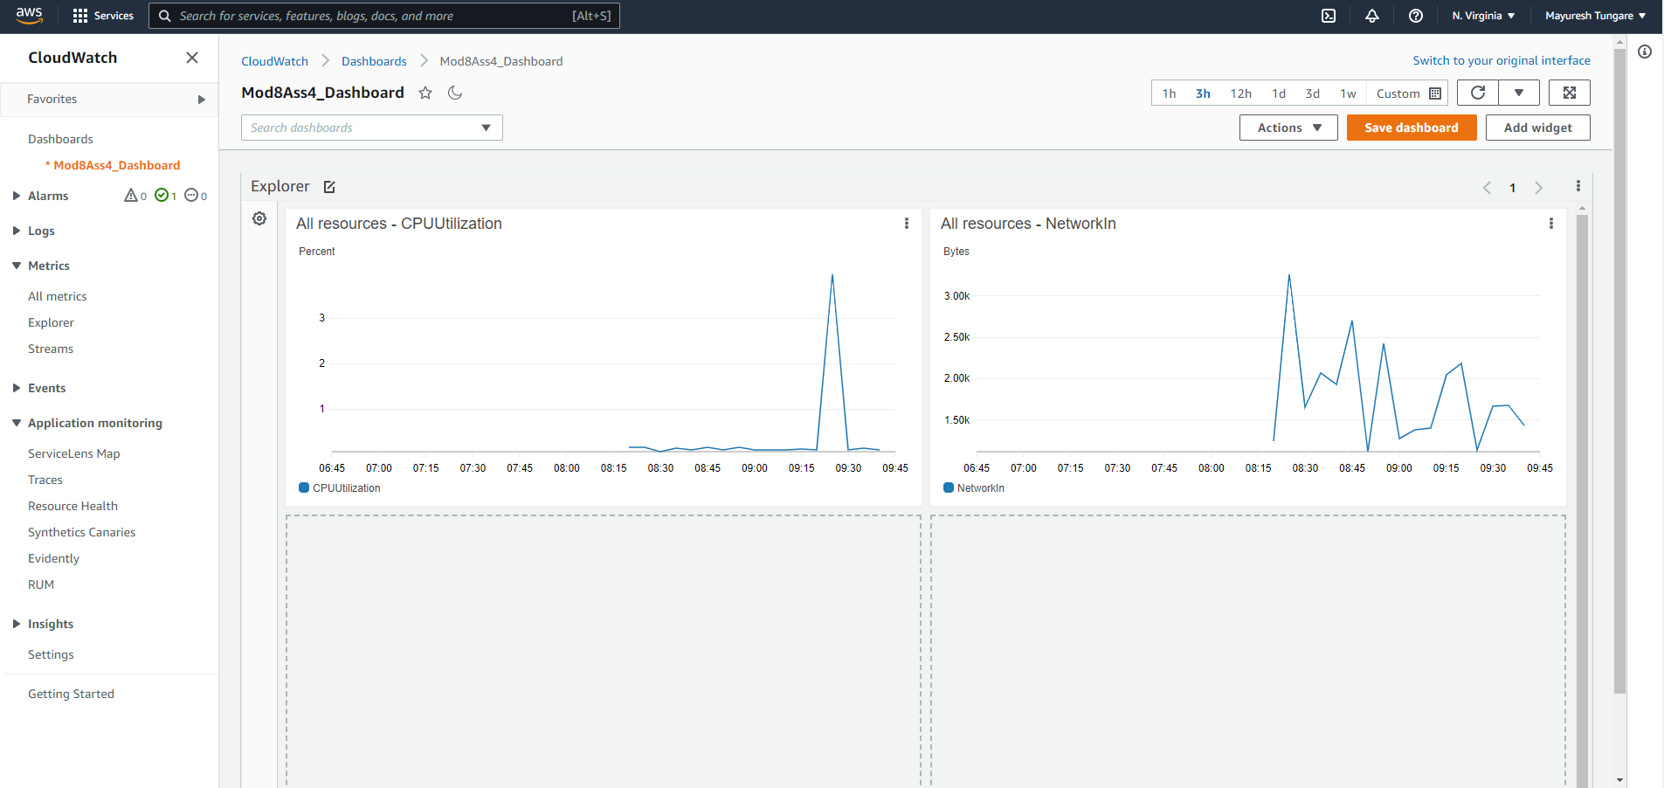

1. Thus this assignment is now complete.